DATA STRUCTURE AND ALGORITHMS
Exercise 2: E-commerce Platform Search Function
Scenario:
You are working on the search functionality of an e-commerce platform. The search needs to be optimized for fast performance.
Steps:
- Understand Asymptotic Notation:
  - Explain Big O notation and how it helps in analyzing algorithms.
Big O notation describes how the runtime (or memory usage) of an algorithm grows as the size of its input grows. It doesn't measure exact time in seconds — it captures the rate of growth, so you can compare algorithms independent of hardware, programming language, or implementation details.
Big O notation focuses on the worst-case scenario and helps programmers understand how an algorithm will perform when dealing with large amounts of data. It ignores constant factors and lower-order terms, considering only the dominant factor that affects growth.
Importance of Big O Notation
- Performance Evaluation: It helps determine how efficiently an algorithm uses computational resources.
- Algorithm Comparison: Different algorithms can be compared based on their time and space complexities.
- Scalability Analysis: It predicts how an algorithm will perform as the input size increases.
- Optimization: Developers can identify inefficient algorithms and replace them with better alternatives.
Common Time Complexities
Big O Notation | Complexity Type | Example
O(1) | Constant Time | Accessing an array element
O(log n) | Logarithmic Time | Binary Search
O(n) | Linear Time | Linear Search
O(n log n) | Linearithmic Time | Merge Sort
O(n²) | Quadratic Time | Bubble Sort
O(2ⁿ) | Exponential Time | Recursive Fibonacci
O(n!) | Factorial Time | Brute-force permutations

  - Describe the best, average, and worst-case scenarios for search operations.
When analyzing a search algorithm, we look at three scenarios because the same algorithm can take very different amounts of time depending on where the target is, or whether it exists at all.
Linear SearchLinear search checks each element one by one, starting from the beginning, until it finds the target or reaches the end.
- Best case — O(1): The target is the very first element checked. Found immediately, regardless of how large the list is.
- Average case — O(n): On average, the target is somewhere in the middle, so roughly n/2 comparisons are needed. This still simplifies to O(n) since constants are dropped in Big O.
- Worst case — O(n): The target is the last element, or it isn't in the list at all. Every single element must be checked.
Binary Search
Binary search works only on a sorted list. It repeatedly compares the target to the middle element and discards the half of the list that can't contain it.
- Best case — O(1): The target happens to be the middle element on the very first comparison.
- Average case — O(log n): Typically, several halvings are needed before the target is found — proportional to log₂(n).
- Worst case — O(log n): The target is found only after the list has been halved all the way down to a single element (or determined to be absent). Even in this case, the number of comparisons is log₂(n), which is still very fast compared to linear search's O(n).

- Setup:
  - Create a class Product with attributes for searching, such as productId, productName, and category.
- Implementation:
  - Implement linear search and binary search algorithms.
  - Store products in an array for linear search and a sorted array for binary search.
- Analysis:
  - Compare the time complexity of linear and binary search algorithms.
Search Algorithm | Best Case | Average Case | Worst Case
Linear Search | O(1) | O(n) | O(n)
Binary Search | O(1) | O(log n) | O(log n)

  - Discuss which algorithm is more suitable for your platform and why.
For an e-commerce platform, Binary Search is more suitable because online stores often contain thousands or even millions of products. Binary Search can locate a product much faster than Linear Search due to its O(log n) time complexity.
Output:
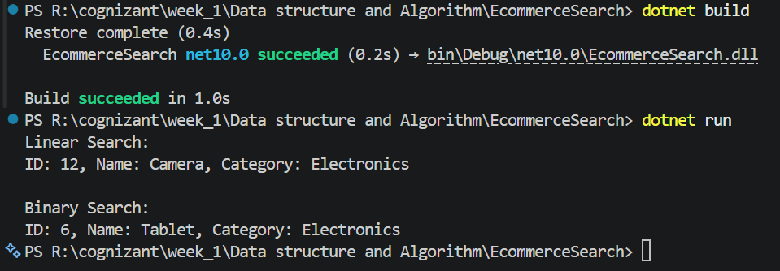

Exercise 7: Financial Forecasting
Scenario:
You are developing a financial forecasting tool that predicts future values based on past data.
Steps:
- Understand Recursive Algorithms:
  - Explain the concept of recursion and how it can simplify certain problems.
Recursion is a programming technique where a function solves a problem by calling itself with a smaller or simpler version of the same problem, until it reaches a base case that can be answered directly without further recursion.
Every recursive algorithm has two essential parts:
- Base case: the simplest version of the problem, which stops the recursion (e.g., "0 years from now, the value is just the present value").
- Recursive case: breaks the problem into a smaller sub-problem and calls itself again, eventually progressing toward the base case.
- Recursion simplifies problems that have a repetitive structure, such as tree traversal, factorial calculation, Fibonacci sequence generation, and financial forecasting.

- Setup:
  - Create a method to calculate the future value using a recursive approach.
FV(n) = FV(n-1) × (1 + growthRate), Base case: FV(0) = Present Value
- Implementation:
  - Implement a recursive algorithm to predict future values based on past growth rates.
- Analysis:
  - Discuss the time complexity of your recursive algorithm.
For each year, the recursive function makes one recursive call.T(n) = T(n-1) + O(1)
Therefore: Time Complexity = O(n)where n is the number of years.

Space Complexity: Because each recursive call is stored on the call stack:

Space Complexity = O(n)

  - Explain how to optimize the recursive solution to avoid excessive computation.
The recursive solution can become inefficient for large values of n because it creates many function calls and consumes stack memory.

1. Use Iteration
An iterative approach eliminates recursive calls and reduces memory usage.
Time Complexity: O(n) Space Complexity: O(1)

2. Use Memoization
Store previously computed results and reuse them instead of recalculating.
Time Complexity: O(n) Space Complexity: O(n)

3. Use Mathematical Formula
Directly compute:
Future Value = Present Value × (1 + Growth Rate)^Years

Using built-in functions:
double futureValue = currentValue * Math.Pow(1 + growthRate, years);
This is the most efficient approach for financial forecasting.

https://github.com/monu9523/cognizant/tree/main/Data%20structure%20and%20Algorithm

